Financial Fraud Prediction with Machine Learning Techniques
IST 707 : Samuel Remp | Justin Forkert | Erika Haase

Abstract:
Financial fraud prevention is needed in an expanding eCommerce environment so that the benefits of credit are widely available and convenient, and the amount and cost of fraud is reduced. Machine Learning methods may lead to faster and more accurate transaction flagging. A variety of methods were tested on a synthetic dataset to show how these methods could be applied using PCA Dimensionality Reduction and XGBoost.

1 Introduction
Financial fraud, including credit card fraud, is a widespread problem that costs customers, businesses, and credit companies time and money. The US alone suffered over $13 billion in losses in 2022 ^{[2]} and every $1 fraud attempt costs a predicted $4.41^{[3]}.
Our objective is to use machine learning techniques to increase efficacy in flagging fraudulent transactions based on behavior patterns for smaller credit companies. The metrics for improvement are increasing flags on actual fraud while not over-flagging legitimate transactions resulting in customer inconvenience. We believe this will reduce fraudulent transactions processed and the total cost incurred from fraud. Moreover, our ability to protect account identities will increase customer trust.

2 Literature Review
2.1 Problem statement
The ability to weather fraudulent transaction costs creates a high barrier of entry for both users and dispensers of credit. To operate profitably, consumers and creditors require a method of preventing fraud and its associated costs. To prevent all fraud, a company could require that all transactions are verified, but that would be highly inconvenient for users. A balance needs to be available that reduces risk for individuals and companies that still allows for the convenience that the financial services are intending to offer.
2.2 Dataset Selection
Due to the sensitive nature of financial data, datasets to create prediction systems are anonymized and unlabeled. As such, we chose a synthetic dataset to promote a real-world scenario for prediction improvement.
2.3 Method selection
A variety of methods were reviewed as options for improving flagging efficacy. We found that several methods produced positive results. Due to the size of the data, the model ran slowly for many of the options. We chose XGBoost due to the accuracy, low standard deviation, and speed at run-time.
2.4 Similar Methodology
Financial fraud is a highly analyzed topic and many of the same techniques we attempted have been studied^{[5-7]}. Other research presents many of the same common themes that we ran into including data privacy and imbalanced data due to the nature of the industry and problem. Due to the increase in financial service usage, the necessity for this research is continually stressed over the inconvenience of these data issues.

3 Data
Our desire to simulate a real-world setting led us to select a synthetic dataset from Kaggle^{[4]}. This synthetic dataset consists of 11 columns and 1 million rows and includes features typically relevant to fraud detection, such as transaction amount, location, type, and other attributes. There is a dependent column of ‘isFraud’ and a column indicating if the transaction was flagged as fraud. The dataset was generated using PaySim, a financial mobile money simulator specifically designed for fraud detection research.

Fig 1. Sample of Financial Dataset
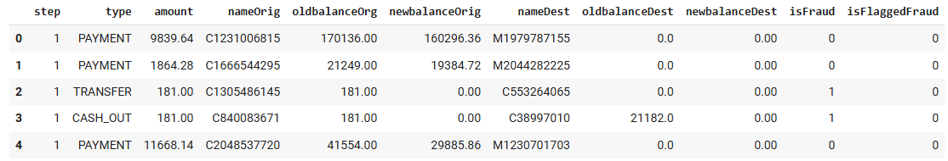

A benefit of using synthetic data allows us to see the features that would typically be available, decide how to clean and scale the features, and rationalize strategic actions for prevention. Another benefit of this dataset was that currency was automatically converted to a standard currency at the time of transaction. In a real-world setting, this would need to be done at the time of transactions to capture currency conversion adjustments.
As mentioned, the challenge with financial data is that fraudulent transactions are a minority of transactions and are underrepresented in the dataset. The previous ‘isFlaggedFraud’ is on large transactions over 200,000. This would be a low bar for a flagging system.
Amount and Transfer Type appeared to have the highest correlations; however, the features did not appear to be highly correlated with the ‘isFraud’ column.

Fig 2. PLACEHOLDER TO GAUGE SIZE
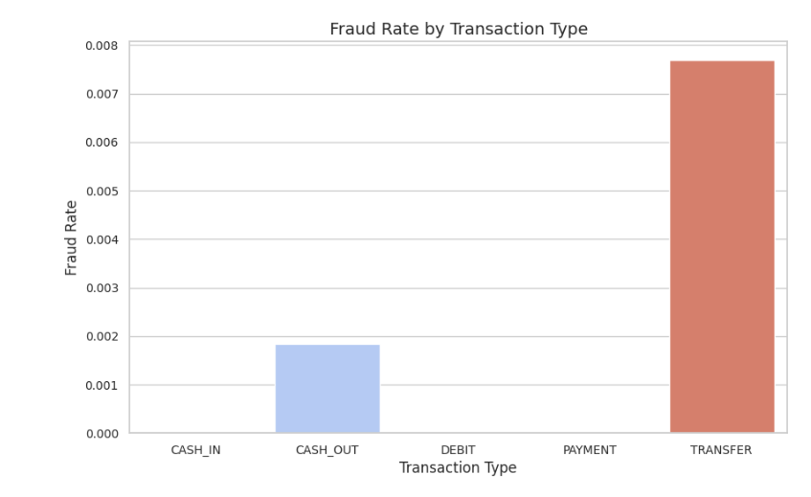

Fig 3. PLACEHOLDER TO GAUGE SIZE


Fig 4. PLACEHOLDER TO GAUGE SIZE


4 Methods
4.1 Cleaning and Preprocessing
The data was checked for na results, amounts were scaled, and payment types were encoded. The payment types were important to breakout as ‘Transfers’ and ‘Cash Out’ are more likely to be flag than ‘Cash In’. Columns that did not provide valuable insights were dropped including previous flags and account names. With a large dataset, we didn’t want to include unnecessary columns that would slow the model or add unnecessary noise. Principal Component Analysis was used to reduce dimensionality. A threshold of 95% was used to determine how many new feature columns to include.
4.2 Methods Tested
The data was split in train and test sections and the training data was then looped through several models including Decision Tree, SGD Classifier, Random Forest, KNN Classifier, SVC, Logisitic Regression, and XGBoost. The Decision Tree, Random Forest, KNN Classifier, and XG Boost yielded the best results. The SGD Classifier, SVC Eval, and Logistic Regression (using liblinear) were rejected due to low results of F1 and high standard deviations.
4.3 Method Selected
Due to the size of the dataset, we chose to move forward with the XGBoost due to positive results and faster run-time.

Results
The XGBoost yielded an F1 score of 99.87% with 0 standard deviation. We were concerned with overfitting; however this provided the best result and similar results as other models. We used Cross validation to estimate performance.
As we used PCA, the new columns were used for evaluation, but the amount appeared to be the most influential column. For the type, ‘Transfers’ and ‘Cash Out’ were the more telling types over ‘Cash In’.

Fig. 5 Results
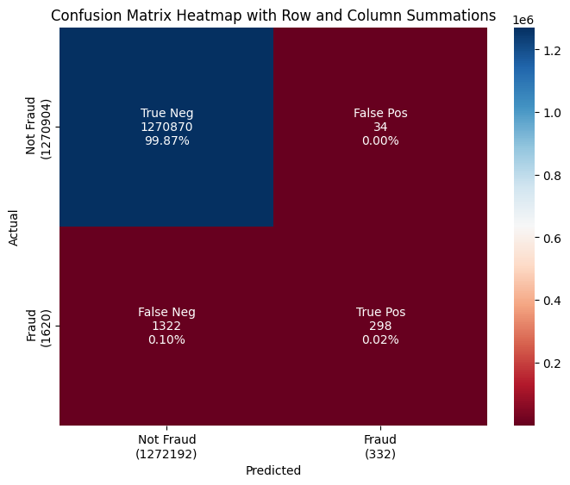

Discussion
We felt that the model we provided gave better results that solely flagging transactions above $200,000. This would provide a higher success rate for flagging fraud. However, this would add flagging transactions that are not fraud as fraud. This could add additional customer frustration.
We would want to continue testing new methods and ways to break up the dataset to get more realistic flagging for transactions that are fraud and less inaccurate flagging on actual customers.
Additional data would help to find anomalies and pattern detection. We used a synthetic dataset that allowed us to have a clear understanding of what we were analyzing. However, the sensitive nature of financial analysis opens room for more unsupervised techniques that could lead to fraud prevention without impacting security.

Limitations
The accuracy score provided by the model would provide the fraud detection needed to prevent the transactions from being processed and save the additional costs of correcting the issues associated with fraud. The method of flagging transactions over 200,000 in the initial dataset provided would have prevented the most expensive errors but was not an accurate way to flag fraud. The stakeholders would want to know how many times we would flag customers with legitimate transactions as fraud (False Positives) and the materiality of the amount saved with the new system. Additionally, smarter prevention techniques make for smarter criminals. How would the system continue to learn from the incoming data and continue to adjust to keep this accuracy rate?

Future Work
In a real-world setting, the analysis that we performed could be implemented to flag fraud if the amount and type columns are available. As transactions must be flagged quickly when being processed, a pipeline would need to be created for fast detection.
Ideally, more data columns could be available including location, purchase type, and more user account behavior to flag if the transaction is outside of regular financial behaviors. The system would need to continue to learn from new emerging patterns to keep the high success rate.
A concern for this type of work is bias by location, organization, or individual. The systems need to be set up in a way that prevents fraud while fairly allowing financial services options.
Citations
[1] Kaggle, Edgar Lopez-Rojas Synthetic Financial Datasets For Fraud Detection
[2] https://nilsonreport.com/research-16th-edition/
[3] https://risk.lexisnexis.com/insights-resources/research/us-ca-true-cost-of-fraud-study
[4] “Credit Card and Other Financial Instrument Fraud.” United States Sentencing Commission, 27 Aug. 2024, www.ussc.gov/research/quick-facts/credit-card-and-other-financial-instrument-fraud.
[5] C. Huot, S. Heng, T. -K. Kim and Y. Han, "Quantum Autoencoder for Enhanced Fraud Detection in Imbalanced Credit Card Dataset," in IEEE Access, vol. 12, pp. 169671-169682, 2024, doi: 10.1109/ACCESS.2024.3496901.
[6] Pundkar, S. N., Zubei, M., & Saxena, K. K. (2023). Credit Card Fraud Detection Methods: A Review. E3S Web of Conferences, 453, 1015 https://doi.org/10.1051/e3sconf/202345301015
[7] Lunghi, D., Paldino, G. M., Caelen, O., & Bontempi, G. (2023). An adversary model of fraudsters’ behaviour to improve oversampling in credit card fraud detection. IEEE Access, 11, 1–1. https://doi.org/10.1109/ACCESS.2023.3337635

